Summative Assessment 2 – Data-driven Application
A project by Marcopolo John P. Deocampo

Abstract
The project I have decided to create for this assessment is a simple trivia application. Utilizing the Open Trivia API, I would make a simple application that allows the user to pull any configuration of trivia from the website and engage with it through a simple Tkinter UI and the program that allows the application to function.
For some context, the Open Trivia Database is a public trivia data library that allows all kinds of users to create and use trivia questions. This is done through the Open Trivia API, which is publicly available to anyone who would want to use it for a project.
In order to use the Open Trivia API, one simply needs to generate a specific URL in order to start using it. This URL consists of five customizable options: The number of questions in the trivia, the category of questions, the difficulty of those questions, the type of trivia the user engages with (either a True/False trivia, or a Multiple-Choice trivia), and the encoding format the programmer wishes to use.
All data provided by the API is available under the Creative Commons Attribution-ShareAlike 4.0 International License.
LINK TO THE GITHUB REPOSITORY: https://github.com/TealTophat/cc5-advanced-programming-summative-assessment-2

Project Plan
There were some key milestones I had set out to achieve to complete this project:
1) Understand and utilize the Open Trivia API
2) Program a script that requests the API and processes it into usable variables.
3) Program the script to be able to handle key aspects of a trivia game, such as questions, answer handling, and rewards.
3) Integrate the script into a Tkinter UI that can also handle user inputs.
4) Allow anonymous users to test out the functional application prototype.
4) Design and polish the prototype application to create the final product.
Personally, I am more confident in my scripting skills than my designing skills, and therefore must allocate more time to the overall design and polish of the final application. I decided to handle testing before the final design because I believe that the user would only need the intuition of the application’s function more than the guidance of the UI to use it.
Regarding the first step of using the API, I planned to allow the user to be able to customize nearly all aspects of their trivia. Out of the mentioned options, the user would be able to customize their trivia’s question amount, category, and difficulty. In terms of the trivia type, I kept that locked to True/False-type trivia for the sake of simpler code and UI.
Secondly, the program that would use this API had some very specific goals I intended to accomplish:
The program should be able to:
- Request and successfully obtain an OT API using a generated URL.
- Handle user input to customize the generated URL via variables and string values.
- Process the obtained API into “chunks” that can be usable by the program’s functions and variables (i.e: substituting the “correct_answer” value of the API into a similarly named variable for a function that compared the user’s answer to the correct answer according to the API).
- Have functions that seamlessly integrate into the Tkinter UI.
Finally, I would create a basic Tkinter UI that will form the application’s frontend, allowing the user to easily navigate the trivia program. This UI would consist of multiple Frame objects that contained certain parts of the trivia flow:
- The Main Frame: Contains the main title of the application, as well as a button to begin the application.
- The Selection Frame: Contains entry fields and dropdown menus that would let the user customize their trivia data (in which the data from the menus would be inserted into the URL that would be used to request an API), and a button to start the trivia.
- The Trivia Frame: The main looping point of the program. Contains a label that displays the current question, and the two buttons to answer True or False.
- The Intermission Frame: A Frame simply containing a label that shows the result of the user’s answer in the Trivia frame and a button to continue. The python function associated with this frame contains a conditional that determines if the trivia either moves on to the next question or ends.
- The Results Frame: Contains a congratulatory message that shows the user their accomplishments, and a button to go back to the Main frame. The function associated with this frame also resets all the necessary variables and functions to their starting state.
In conclusion, the final product of the python application would be able to handle the requesting and processing of the API that the user customizes. Then, the user will proceed through answering each of the trivia questions before being shown their performance at the end of the program. If the user wishes, they may restart the application program to try the trivia again, or experience a new trivia set.

Evidence of Design
Below are pieces of evidence regarding the creation and design of the application.
- UML Class Diagram
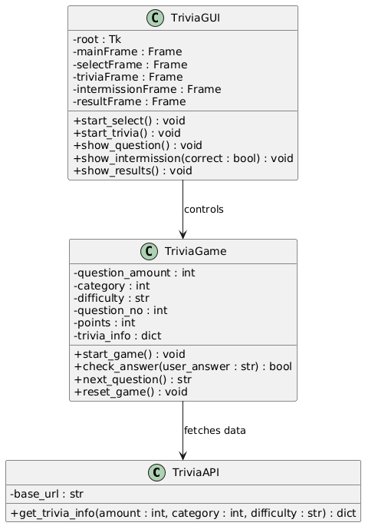
- Flowchart Diagram
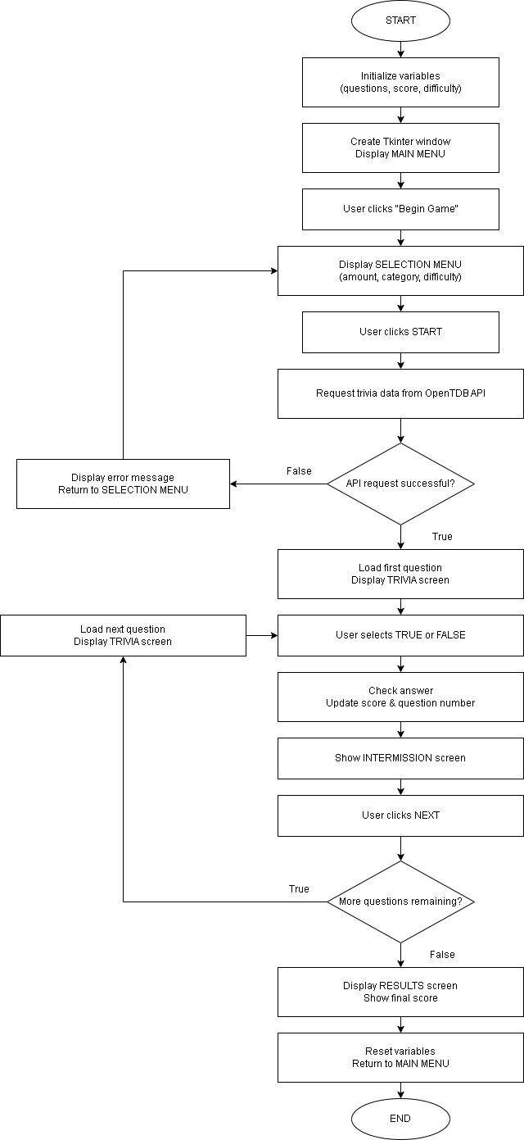

Technical Description & Walkthrough
Below is the link to a public Google Drive that contains both the Technical Description and Walkthrough Video, and the Video Demonstration of the application:
https://drive.google.com/drive/folders/1Ego-39zVBQ8as1_tbbECWHMcxkDhWWqf?usp=drive_link

Testing
As the program allows a user to customize nearly every aspect of their trivia experience using the selection menu, the testing of this project will take place using a controlled format of trivia. For the sake of simplicity, each tester will provide their feedback on a scale of 1 – 10, 1 being the worst and 10 being the best. Each tester will rate their familiarity to the concept of trivia, their ability to understand and navigate the application’s UI, and their final score.
Tester | Trivia Familiarity | UI Handling | Trivia Score
1 | 10 | 10 | 8
2 | 3 | 10 | 2
3 | 10 | 5 | 6

For the most part, the testing yielded good results from their respective testers. One thing to note is that the reason why tester #3 gave a rating of 5 out of 10 in the “UI Handling” category was mainly due to the flow of the trivia, being a question-intermission-question-intermission sequence. Their opinion was that this flow did not feel right to them, and that showing all the results at the end of the trivia would have been better. As much I would have liked to act on this suggestion, the reason I had this flow was so that I could have things be changed in the background during the intermission sections.

Critical Reflection
The process of planning, developing, testing, designing, and documenting this entire project was a very enlightening learning experience for me.
The concept of a trivia application did not seem very innovative, but instead of creating something brand new, I decided that this project would be my demonstration of the concepts I have learned throughout the semester.
In conclusion, I believe that the overall process of conceptualizing, planning, development, design, and testing were all important factors of my programming experience.

Appendix
A) A copy of the application code (in the form of an embedded document, double click to access):

